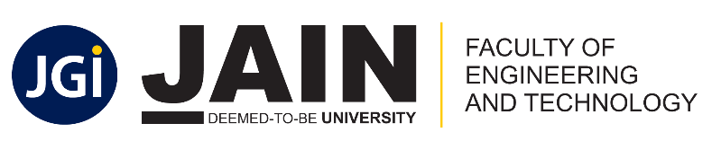

Department of Computer Science and Engineering
School of Computer Science & Engineering
Faculty of Engineering & Technology
Jain Global Campus, Kanakapura Taluk - 562112
Ramanagara District, Karnataka, India
CERTIFICATE

This is to certify that the project work titled “120 Years of Grandeur: Unveiling Trends and Insights in Olympic data” is carried out by Hitha Choudhary G (22BTRAD015), K Shreeshanth Gouda (22BTRAD017), Lakshya Sharma (22BTRAD021), a bonafide student(s) of Bachelor of Technology at the School of Engineering & Technology, Faculty of Engineering & Technology, JAIN (Deemed-to-be University), Bangalore in partial fulfillment for the award of degree in Bachelor of Technology in Computer Science and Engineering, during the year 2023-2024.
Mr. Akash Das | Dr. Aditya Pai, | Dr. Geetha G
AVP and Project Manager  Futurense Technologies  Date: 10-04-2024 | Program Head,  Computer Science and Engineering,  School of Computer Science & Engineering  Faculty of Engineering & Technology  JAIN (Deemed to-be University)  Date: 10-04-2024 | Director,  School of Computer Science & Engineering  Faculty of Engineering & Technology  JAIN (Deemed to-be University)  Date: 10-04-2024

Name of the Examiner Signature of Examiner
1.

2.

